**

“This is my own work. I have not copied any of it from anyone else.”

**November 2024**

**Michael Le 21689299**

**Introduction**

I have reviewed and extended the meta-analysis by J. Wang et al., published in the journal Neuroscience and Biobehavioral Reviews. It includes 30 independent observations from three cognitive domain categories on 3608 records of middle to old autistic adults under different ranges of sub-studies conditions and cross-sectional designs.

Among different types of participant information, cognitive assessments and summarized findings for cognitive study outcomes are categorized into 'cognitive domains. It is crucial to confirm that ASD diagnostics have scrutinized whether incoming and recurring participants have maintained diagnostic stability, including increased retention rates. The primary prespecified objective of performing this meta-analysis to examine on cognitive ability on adults diagnosed with autism spectrum disorder assessing different types of neurotypical controls and cognitive domains.

The key findings from existing claims are that autistic adult’s manifest unique deviations within neurocognitive domains associated with neurotypical controls and that, with direct implications, they are more prone to experiencing early impairments or developing pathological aging compared to neurotypical individuals and behaviours. The suggested implications should be considered to enhance their cognitive process and assessments based on their cognitive ability and stability over time.

**Methods**

The authors provide a quality assessment of selected articles on Cognitive dysfunctions and structural measures of the human brain changes in autistic adults: A systematic review and meta-analysis [2] statement; details on further implications and conventions on cognitive changes and structural brain changes are included.

The outcome of interest was assessing aging-related cognitive and brain variations were assessed by three different categories of cognitive domains: such as global cognitive function, executive function, and episodic memory were applied for this analysis, reported as estimated Standardised Mean Differences (SMDs) in Cognitive deviations. The authors noted that the standardized mean differences (SMDs) were calculated using Hedge's g, which represents the effect size in the meta-analysis. A positive Hedge's g indicated that neurotypical controls outperformed autistic individuals. [1]. These estimates and their associated 95% Confidence Intervals (CIs) were calculated using R. This statistical software programming language is practical for creating meta-analyses and regressions despite needing to be mentioned on paper. It can allow for the performance of meta-analytic estimates and forest plots, which were produced using the Random Effects Model (REM) used in the paper during the analysis.

Aside from the overall estimate from all 30 interventions, three subgroup analyses (A, B, and C) were conducted on the cognitive domain. The following studies were partitioned into the following stages: (A) global cognitive function compressed into one stage, (B) executive function compressed into two stages, and (C) episodic memory compressed into two stages.

The authors report using Egger's Q test to assess the evidence of between-subgroup differences for different cognitive domains in true SMDs. The risk of publication bias was assessed from Supplementary Figure 5, which contains two figures: (A) this includes some observations that used MMSE to examine cognitive impairment and (B) excluding studies that used MMSE as a screening tool to conclude that the tests were insignificant. Supplementary Figure 6 contains our figures (A) executive function, (B) cognitive processes of flexibility, Planning, (C), and working memory (D) where (A) Egger's test was the only group demonstrating statistical significance. Lastly, Supplementary Figure 7 contains three figures containing episodic memory (A), cognitive process of verbal (B), and visual memory (C) where all tests were not significant: A funnel plot of all 30 observations was produced, similarly for Egger's test for funnel plot asymmetry was conducted [2].

**Main findings**

Note that the positive values of the Hedges test of the SMD indicate that neurotypical controls had a better performance than autistic adults, determining cognitive ability and aging from different cognitive groups. Assuming that all significant levels were predetermined at 5% for each number of studies. The authors state that the overall observations for each sub-group determine where neurotypical controls performed better than autistic adults. For global cognitive function (A) (mean SMD = 0.505, 95% CI = [-0.404, 1.414]). For executive function (B) (mean SMD = 0.257, 95% CI = [0.031, 0.482]). For Episodic memory (C) (mean SMD = 0.145, 95% CI = [-0.068, 0.357]). Note that the diverse range of study conditions and approaches to intervention suggests that we should reasonably expect some heterogeneity to be present, which has implications for our interpretation of the mean SMD. The main findings for subgroup analyses (A) during the cognitive process, (B) and (C) compressed into two stages (cognitive processes and assessments) as follows:

(A)

The estimated mean SMD for test for CFQ was small and significant (mean SMD = 1.365, 95% CI = [1.059, 1.670]); while that for MMSE, MoCA was extensive and not significant (mean SMD = -0.096, the analysis revealed that the SMDs (95% CI = [-0.345, 0.152]) and (mean SMD = 0.251, 95% CI = [-0.103, 0.605])) were not sensitive. The CFQ showed a large effect size (SMD = 1.364, 95% CI = 1.109–1.619, p < 0.001), while the MoCA presented a smaller effect size (SMD = 0.238, 95% CI = [-0.072, 0.548], p = 0.132). A significant degree of heterogeneity was noted among effect sizes (I^2 = 92.687%). However, there was no significant publication bias [2] (Supplementary Figure 5), where the funnel plot does not have any significance for asymmetry.

(B)

During the cognitive process, the estimated mean SMD for test for Working memory was significant related to identifying executive control deviations showed an effect size of (SMD = 0.339, 95% CI = [0.013, 0.666]).; while Flexibility/set-shifting was not significant (SMD = 0.313, 95% CI = [-0.073, 0.700]) similarity for Planning (SMD = 0.057, 95% CI = [-0.365,0.480]. There is a moderate heterogeneity for multiple cognitive processes from four imputed studies (I^2 = 51.483%) that contributed to removing publication bias was significant [2] (Supplementary Figure 6A) where the funnel plot shows signs of asymmetry where (Figure 6B, 6C and 6D) [2] does not show. There are two trail marking tests for the assessment stage for flexibility/set-shifting. The Trail Marking test (SMD=0.615, 95% CI = [0.031,1.200]) was significant, and Card Sorting Tasks (SMD = 0.615, 95% CI = [0.031,1.200]) was not significant. There is a high significant heterogeneity (I^2 = 67.689%) where publication bias was non-significant [2] (Supplementary Figure 6B). Planning contains two different tasks, Assessing Tower tasks and BARD Zoo Map test with the estimated mean SMD test (SMD = 0.228, 95% CI = [-0.218,0.674]) and test (SMD=-0.073, 95% CI = [-0.598,0.451]) were both tests are not significant. Conclude, considerable Heterogeneity (I^2 = 62.040%) has no publication bias. For working memory, there was considerable heterogeneity (I^2 = 62.040%) with no evidence of publication bias. For working memory, the Wechsler Memory Scale assessments demonstrated high effectiveness (SMD = 0.835, 95% CI = [0.434, 1.236], p < 0.001), compared to the Wechsler Adult Intelligence Scale, which showed a smaller effect size (SMD = 0.244, 95% CI = [-0.030, 0.517], p = 0.081).; [2] Supplementary Figure 3) was small and significant. A moderate heterogeneity (I^2 = 33.352%) leads to non-significant publication bias.

(C)

During the cognitive process, the estimated SMD for verbal and visual are not significant given (SMD = 0.172, 95% CI = [-0.114,0.459]) and (SMD=0.111, 95% CI = [-0.204,0.427]) respectively where both values are significant and insignificant. There is a high heterogeneity (I^2=58.727%) leads to publication bias shown no significance. For the assessment phase, on verbal and visual, respectively for immediate recall, the effect size was (SMD = 0.172, 95% CI = [-0.189, 0.533]), while for delayed recall, the effect size was (SMD = 0.091, 95% CI = [-0.307, 0.490]).; recognition: SMD = 0.130, 95% CI =[ − 0.588, 0.328]; [2] this includes visual assessments, with the following effect sizes: immediate recall (SMD = −0.043, 95% CI = [−0.368, 0.281]), delayed recall (SMD = 0.033, 95% CI = [−0.291, 0.357]), and recognition (SMD = −0.093, 95% CI = [−0.506, 0.320]; see Supplementary Figure 4). There was high heterogeneity for verbal memory (I^2 = 69.338%) and moderate heterogeneity for visual memory (I^2 = 48.335%). In all cases, there was no significant publication bias; [2] Supplementary Figure 7A, B, and C) and visual memory [2] suggest that there is insignificant evidence for asymmetry.

**Replication of main findings**

For the i-th observation, the 95% confidence interval CI(i) is used for the actual SMD and Standard Error formulas below:

$$CI\left(\dot{ⅈ}\right)=D\left(ⅈ\right)± φ^{-1}\left(0.975\right)*SE(D\left(i\right))$$

$SE_{D\left(ⅈ\right)}^{2}$ = $\frac{\left(ⅆ_{i}-C_{L}^{\left(i\right)}\right)+\left(C_{u}^{\left(i\right)}-ⅆ_{i}\right)}{2ϕ^{-1}\left(0.975\right)}=\frac{C_{u}^{\left(i\right)}-C_{L}^{\left(i\right)}}{2ϕ^{-1}\left(0.975\right)}$

Assuming it follows under a standard normal cdf distribution, where D(i) is the observation estimator of the actual SMD, and standard error $SE(D\left(i\right))$. In addition, $CL\left(i\right)$ and $CU\left(i\right)$ represent lower and upper limits for the confidence interval. Containing all meta-estimated SMDs, associated confidence intervals, and I^2 values, this can be achieved by applying similar meta-analysis methods, such as the meta for package in R to determine the study effects using Hedges estimator ${\hat{τ}}_{HE}^{2}$, between study variances **[4]** assuming they are equal and inverse variance weights, thus, we use SMD. Associated I^2 statistic using the RMA function, where the ith observation of the argument vi was set to $SE_{D\left(ⅈ\right)}^{2}$,and that ***yi***is equal to ***d(i)***. Using the funnel plot and Egger's test, p-values were executed using the funnel and regression test. To observe comparisons of each of the study weights demonstrated with the observations reported rough estimates during the 4th Quiz given the standard error as a rough method to perform these metrics to test any significance for different cognitive domains for autistic adults. It was unclear which command was used to provide 95% CIs for I^2 under the random effects model; this can be achieved manually using only the meta for the package to match from the paper. In all relevant tests from all unique cognitive groups and studies, the significance level was prespecified at 5%; see Figures 1,2 and 3 below.

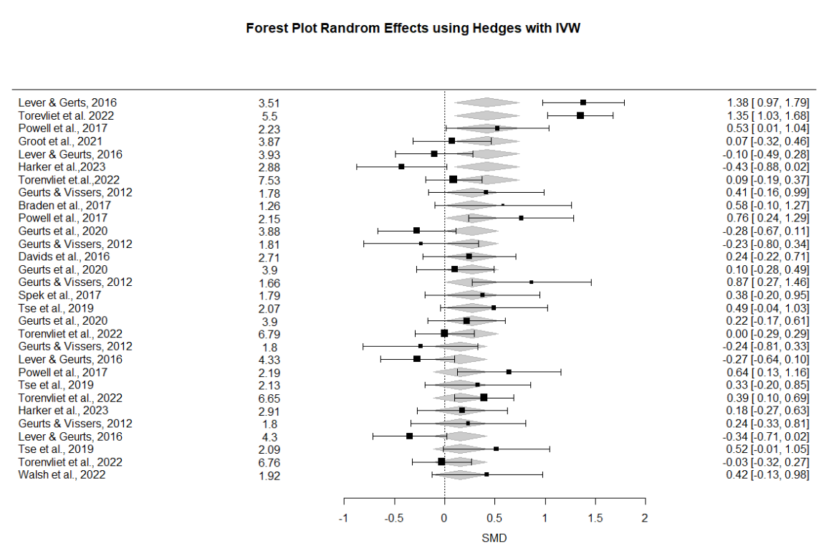

**Figure 1. Forest Plot Random Effects using Hedges estimator, using forest function for 30 observations produced using the metaphor package.**

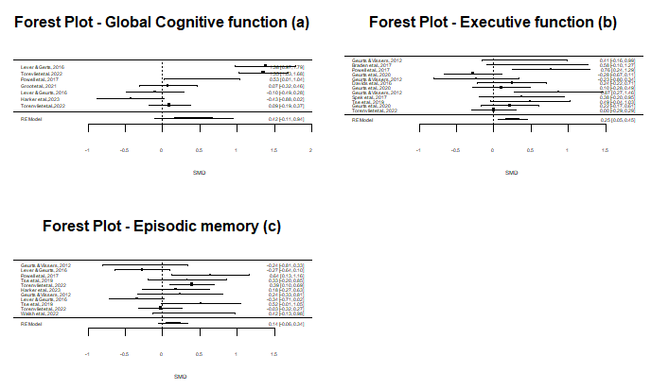**Figure 2. Forest Plot Random Effects using Hedges estimator, using forest function for different cognitive domains.**

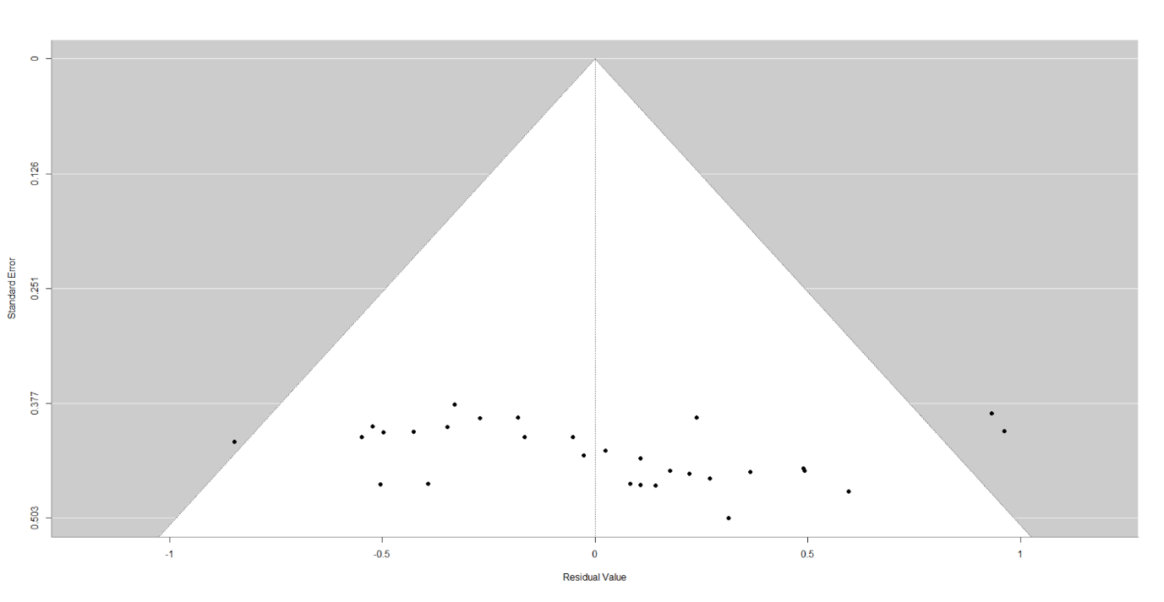

**Figure 3. Funnel Plot for all 30 observations.**

(Egger’s test for funnel plot asymmetry: z = 1.4209, p=0.1553)

**Limitations**

It is worth investigating other estimators than Hedges as our only model as a limitation for the random effects model after applying the replication of the main findings during the analysis. Proper examples that can be appliable here, such as DL, Maximum Likelihood, Restricted Maximum Likelihood, Hunter Schmidt, and Hedge's estimators, were observed in neither the meta-estimate nor the associated upper and lower confidence limits. Though I^2 varied between 79.02% (DL), 76.02% (HE), 77.89% (REML), 76.12%(HS), 77.85%(SJ), 75.48% (ML), 77.06% (EB) and 77.06% (PM) [4] (see Figures 5-11 in the R-Code). The authors did not mention the method behind the Q-test in the paper, but it is worth mentioning that it can be achieved using a summary function from the meta for the package. Where the Q-test for Heterogeneity remained insignificant at the 5% level throughout, see Figure 4 assuming we do not take account of any moderators. Hence, the choice of estimator did not impact the conclusions of the primary analysis. Rather than extend the sensitivity analysis to subgroupings, we conducted three meta-regressions using the categories in subgroupings (A), (B), and (C) as moderators evaluated individually. While our meta-regressions assume that the subgroups share a standard heterogeneity parameter, they can investigate the amount of Heterogeneity explained by the moderators and the magnitude of the associated effect shown in Figures 4A, 4B, and 4C. The Hedges estimator was used to ensure consistency with the original paper. For (A), we found significant evidence at the 5% level that global cognitive function on neurotypical controls was less effective and performed better than autistic adults on average. We estimate the average difference in SMD (est. SMD change = 0.2646 (Full Model in Figure 4)- 0.4155 (estimator from Figure 4A)= -0.1509, 0.95% CI = [-0.1105, 0.9415], p = 0.1316). There is an slight change in I^2 (I^2 = 92.56%) compared to the complete REM meta-analysis (I^2 = 75.82%), which is an indicator that the (A) moderator may explain some of the between-study variability. The RMA function's Q-test did detect significant residual Heterogeneity (QE = 81.7560, p = < .0001).

**Extensions**

It is worth investigating other estimators than Hedges as our only model as a limitation for the random effects model. After applying the replication of main findings during the analysis. Proper examples that can be appliable here such as DL, Maximum Likelihood, Restricted Maximum Likelihood, Hunter Schmidt and Hedge’s estimators, was observed in the meta-estimate nor the associated upper and lower confidence limits. Though I^2 varied between 79.02% (DL), 76.02% (HE), 77.89% (REML), 76.12%(HS), 77.85%(SJ), 75.48% (ML), 77.06% (EB) and 77.06% (PM) **[4] (see Figures 5-11 in the R-Code)**. The authors did not mention the method behind Q-test in the paper, but it is worth mentioning that can be achieved using summary function from the metafor package. Where the Q-test for heterogeneity remained insignificant at the 5% level for throughout **see Figure 4** assuming we not take account of any moderators. Hence the choice of estimator did not impact the conclusions of the main analysis.

Rather than extend the sensitivity analysis to subgroupings, we conducted 3 meta-regressions using the categories in subgroupings (A), (B) and (C) as moderators evaluated individually. While our meta-regressions assume that the subgroups share a common heterogeneity parameter, they have the advantage of being able to investigate the amount of heterogeneity explained by the moderators, and the magnitude of the associated effect shown in **Figures 4A, 4B and 4C**. The Hedges estimator was used for consistency with the original paper. For (A) we found significant evidence at the 5% level that global cognitive function on neurotypical controls were less effective had a better performance than autistic adults on average, and we estimate the average difference in SMD (est. SMD change = 0.2646 *(Full Model in Figure 4)*- 0.4155 *(estimator from Figure 4A)*= -0.150995% CI = [-0.1105, 0.9415], p = 0.1316). We also observed an increase in I^2 (I^2 = 92.56%) compared to the full REM meta-analysis, (I^2 = 75.82%), which is an indicator that the (A) moderator may explain some of the between-study variability. The rma function’s Q-test did detect significant residual heterogeneity (QE = 81.7560, p = < .0001).

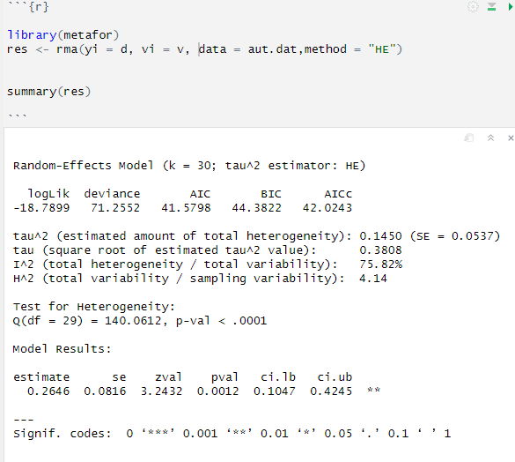

**Figure 4. Summary meta-regression findings using Hedges estimator assume no moderators were considered.**

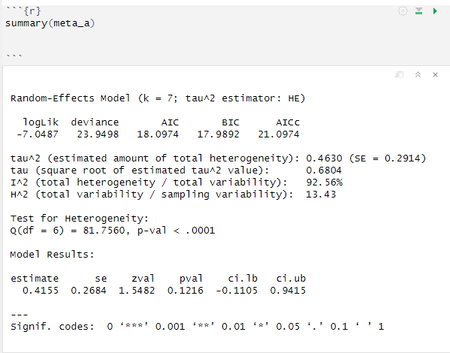

**Figure 4A. Summary meta-regression findings on Type (A) moderator using Hedges estimator.**

For meta-regression (B), we found significant evidence for a change in the actual average SMD going from 'low' to 'high' for neurotypical controls were more effective than autistic adults on average (est. SMD change = 0.2646 (Full Model in Figure 4)- 0.2522 (estimator from Figure 4B) = 0.0124, 95% CI = [0.0529, 0.4515], p = 0.0131). Significant residual Heterogeneity was detected at the 5% level (Q = 22.6707, p = 0.0197, I^2 = 52.79%). For (C), we found significant evidence for a change in the actual SMD (est. SMD change = 0.2646 (Full Model in Figure 4)- 0.1411 (estimator from Figure 4C) = 0.1235, 95% CI = [-0.0552, 0.3374], p = 0.1590). Significant evidence of residual Heterogeneity was detected (Q = 24.2420, p = 0.0070, I^2 = 55.30%).

**Figure 4B. Summary meta-regression findings on Type (B) moderator using Hedges estimator.**

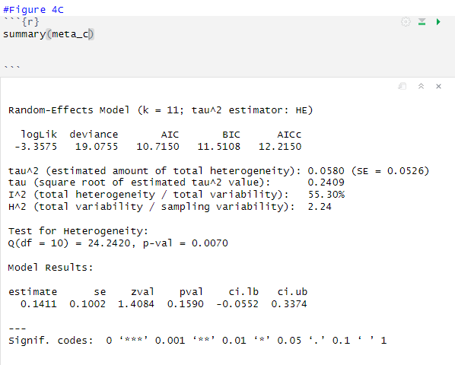

**Figure 4C. Summary meta-regression findings on Type (C) moderator using Hedges estimator.**

**Conclusion**

We have partially replicated the essential results for the meta-analysis. Our additional investigation evidence is in favour of the author's conclusion regarding middle-aged autistic adults having a steady decline in cognitive control, similarly, compared to neurotypical behaviour due to aging. According to the paper, it is unable to find evidence to suggest neurotypical controls performed better than autistic adults in all categories. While we support the authors' conclusions, we caution that statements about the mean SMD should generally not be applied to study-level SMDs. Furthermore, meta-regressions typically suffer a high risk of confounding due to small sample sizes and the fact that the data does not form a controlled sample. These facts suggest that we interpret any indicators of causality. The results hint at informative designs for future observations through extensive research, and the evidence is concise enough to support the author's claim.

**References**

* [1] DataCamp. (n.d.). *rma.uni: Meta-Analysis via Linear (Mixed-Effects) Models*. <https://www.rdocumentation.org/packages/metafor/versions/2.4-0/topics/rma.uni>
* [2] Higgins, J. P., & Thompson, S. G. (2002, May 21). *Quantifying heterogeneity in a meta-analysis*. Wiley Online Library. <https://onlinelibrary.wiley.com/doi/10.1002/sim.1186>
* [3] Nordmann, A. J., Kasenda, B., & Briel, M. (n.d.). *Meta-analyses: What they can and cannot do*. Swiss Medical Weekly. <https://smw.ch/index.php/smw/article/download/1434/1753?inline=1>
* [4] Wang, J., Christensen, D., Coombes, S., & When, Z. (2024, July 4). *Cognitive and brain morphological deviations in middle-to-old aged autistic adults: A systematic review and meta-analysis*. ScienceDirect. <https://www.sciencedirect.com/science/article/pii/S0149763424002513?ref=pdf_download&fr=RR-2&rr=8dc3ce496a882eb2#bib75>
* [5] Wang, Z. (2024, February 27). *Cognitive and brain morphological deviations in middle-to-old aged autistic adults: A systematic review and meta-analysis: Appendix A. Supplementary Material*. ScienceDirect. <https://www.sciencedirect.com/science/article/pii/S0149763424002513?ref=pdf_download&fr=RR-2&rr=8de3d3a84ad62e94>